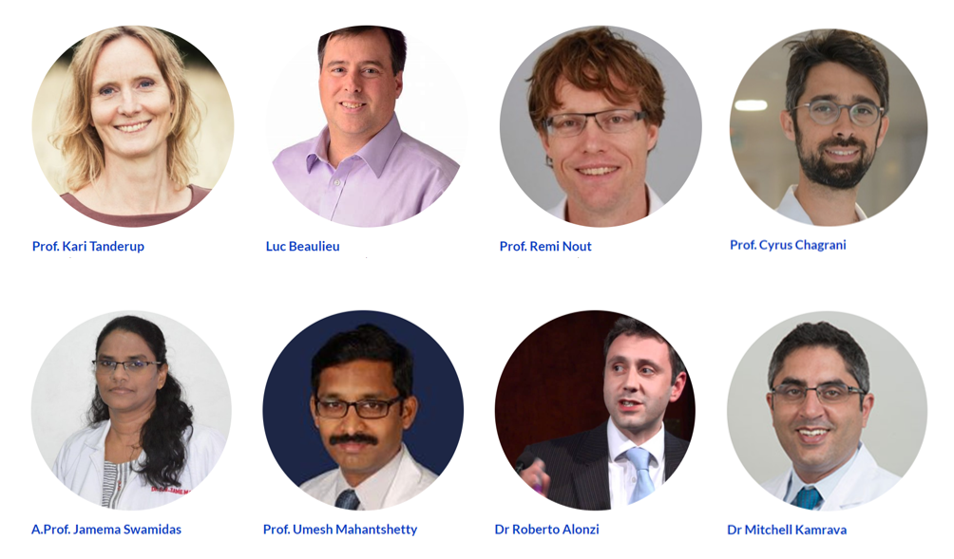  - 25-27th feb 2021  australasian brachytherapy group 30th annual scientific meeting  The ABG’s first virtual interactive event!  Dear friends and colleagues,  It is with great pleasure I welcome you to a new format for the 30th Annual Scientific Meeting of the Australasian Brachytherapy Group. As we navigate our way through the unprecedented year that is 2020, we have all had to adapt and innovate to provide ongoing care to our patients as well as rethink how we interact and connect with each other.  ABG2021 will be an entirely virtual meeting, and we’re thinking outside the box to design an exciting, interactive event. We will be bringing you an international line-up of Brachytherapy All Star speakers, hosting our first Brachytherapy Film Festival and providing the opportunity to learn, share, network and interact on a customised online platform.  We look forward to seeing you online in February 2021!  Regards,  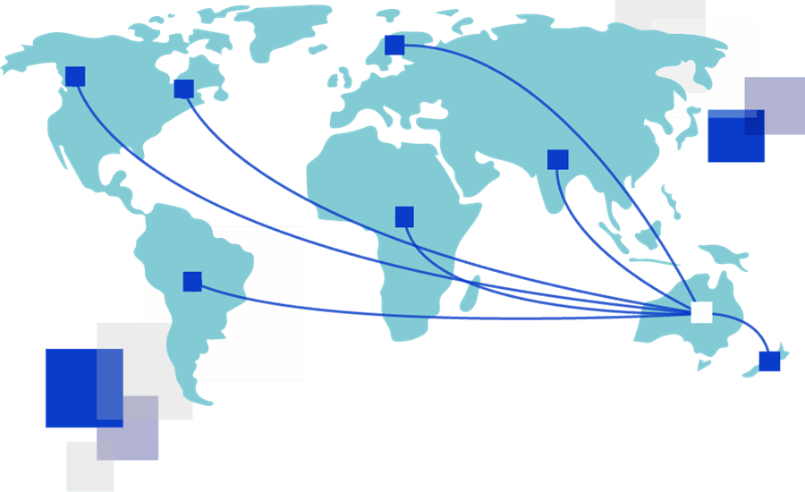  Convenor, Dr Jennifer Chard and the organising committee
  Registration is open! Earlybird pricing ends 22nd January
  ____
  Call for Papers open! Submissions close 4th December
  ____
  Our theme: Outside the Box
  ____
  Brachy Film Festival! Film submissions close 8th January
  ____
  Program
  Coming Soon!
  Follow us:
  @AusBrachy
  #ABG2021
  https://abg2021.cw3.events
